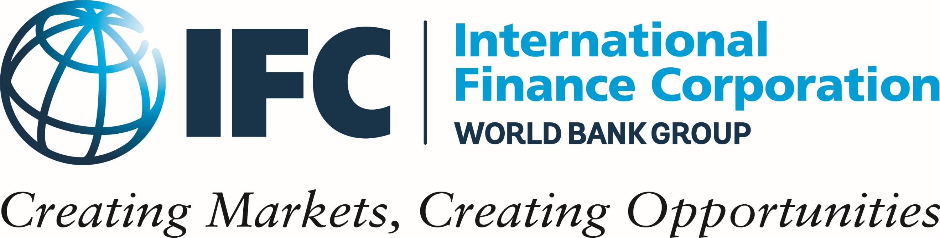

IFC Master Trainer in Facilitating Face-to-Face Learning Certification Program
Program Information Document

IFC (www.ifc.org) - a sister organization of the World Bank (www.worldbank.org ) and member of the World Bank Group - is the largest global development institution focused on the private sector in developing countries. IFC finances private sector businesses in emerging markets, mobilizes capital in international financial markets, helps clients improve social and environmental sustainability, and provides advisory services both to businesses and governments.
IFC has extensive experience in promoting, conducting, and evaluating learning and performance initiatives. Our own research, as well as feedback and demand from our diverse client base, shows a deep need and opportunity in the performance and learning space in emerging markets.

IFC is happy to announce the launch of its Master Trainer in Facilitating Face-to-Face Learning (MT in FFF) Certification Program for 2020.

An MT in FFF is authorized to offer IFC’s train-the-trainer workshop - Facilitating Face-To-Face Learning (FFF) and the internationally recognized IFC-LPI TPMA certification – a joint certification of IFC and the Learning and Performance Institute (www.thelpi.org ).

Why become a certified MT in FFF?

Earning your Master Trainer certification and the badge that now follow your name will make a statement about the expertise and valuable services you bring to the market. It will also give you the following advantages:

- Recognition that you have competency in teaching the FFF course and assessing the skills of other trainers, with the credibility and respect that this implies.
- A new revenue stream. Once you are certified and licensed, you gain rights to offer IFC’s copyrighted FFF course and the IFC-LPI TPMA certification to your new and existing customers.
- Increased visibility to the IFC and other development and professional organizations.

What is expected of an MT in FFF?

As an MT in FFF, you are expected to train, assess, and coach other trainers. You should demonstrate professional behavior, commercial ability to market the FFF at a large scale, and motivation to support the IFC mission of promoting sustainable private sector growth.

No fees are required for participating in the program. However, candidates who fail to complete requirements might be charged the costs incurred by IFC.

What qualifications must MT in FFF candidates have before applying to the program?

- Six (6) year experience or more in facilitating face-to-face learning
- A bachelor’s degree or more in a relevant field
- Based in an emerging country, or have adequate work experience in one
- Good comprehension of the English language
- IFC-LPI TPMA certification (an equivalent certification in facilitation skills might be considered)

Will all candidates with these qualifications be admitted to the program?

No. Qualified candidates undergo a competitive selection to be admitted to the MT in FFF program. To apply, fill in and submit the program application form. IFC will review all applications and will conduct personal interviews to select candidates who have the right experience, skills, and fit to become an MT in FFF.

The application form consists of your:
- Personal profile
- Motivation statement
- Commercial Promotion Plan for the FFF course
- References
If you are shortlisted, an IFC representative will contact you to book a date and time for the interview.

IFC considers the following factors when selecting candidates:
- Educational achievements
- Experience in:
  - Facilitation skills
  - Coaching and other skills related to training and learning
  - Emerging markets
  - One of the following industries (Banking and Financial Services, Agriculture, Manufacturing, Information Technology)
  - Gender initiatives and projects
- Score achieved in the IFC-LPI TPMA certification (or equivalent)
- Fit of the candidate’s goals with IFC’s mission and goals
- Clarity and soundness of the candidate’s Commercial Promotion Plan for the delivery of the IFC FFF and the IFC-LPI TPMA certification
- Professional behavior and attitude
- English language proficiency or fluency

Once admitted to the program, what must candidates demonstrate to achieve MT in FFF certification?

After being admitted to the program, you will be required to successfully complete:
- IFC-LPI TPMA Assessment Skills workshop (online) and related assessment
- IFC FFF Course Orientation workshop (online) and all its work assignments

Candidates who successfully complete the program requirements will be requested to sign the Master Trainer Licensing Agreement granting them the right to offer the IFC copyrighted FFF course, and the IFC-LPI TPMA certification as part of their business services. Details on the Licensing Agreement will be discussed with the shortlisted candidates in the interview.

How long does it take to become Licensed by IFC as an MT in FFF?

The MT in FFF certification program is offered once a year and spans about three months from the day IFC announces the start of accepting candidates’ applications. For 2020, key dates are as follows:

- February 23, 2020: deadline for you to submit your application
- February 24 - March 6, 2020: interviews with shortlisted applicants (exact date to be agreed if you are shortlisted)
- March 19, 2020: notification of selection results announced by IFC
- March 23 - April 4, 2020: if selected, you will be required to attend the IFC-LPI TPMA Assessment Skills workshop (online) and submit related assessment
- May 4 – May 18, 2020: if selected, you will be required to attend IFC FFF Course Orientation workshop (online) and complete its work assignments

To apply for the program, please complete the attached application form and return it no later than Sunday 23rd of February, 2020 to the email address: ifc_mt_certification@ifc.org.

Please click here for more information about the Master Trainer in FFF Certification program.

